Super Tic-Tac-Toe
Multiplayer Platform
Milestone 1 — Database Design & ERD

Version Control Document | April 2026

1. System Overview
Super Tic-Tac-Toe is a competitive online multiplayer platform that extends classic Tic-Tac-Toe into a strategic, skill-based game with ranked play, tournaments, social features, and chat. The platform supports multiple game variants, group communities, and a persistent rating system based on ELO.

1.1 Application Workflow
The following diagram illustrates the high-level workflow of the platform — from player registration through game play, tournament participation, and social interaction:

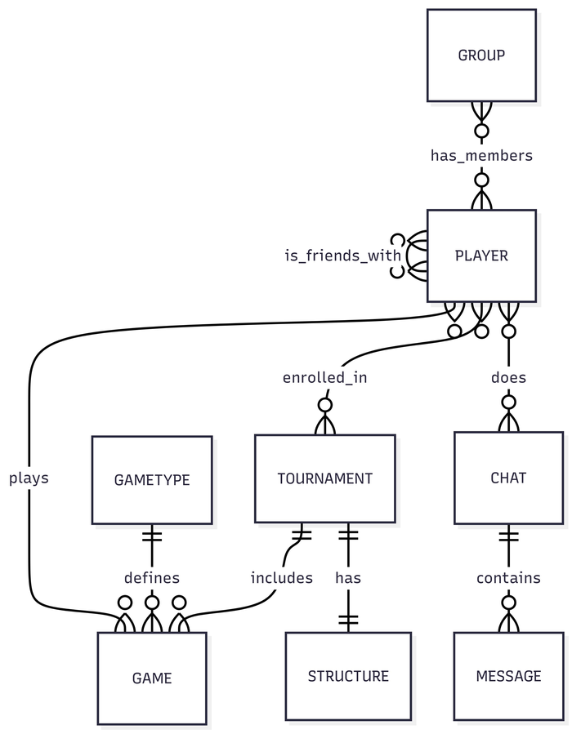
Figure 1 — Player Engagement & System Workflow

1.2 Core Modules
The system is divided into four logical modules:
- Game Engine — manages game types, game instances, moves, and outcomes.
- Tournament System — organises competitive brackets, enrolls participants, and links games.
- Social Layer — handles friend connections, player groups, and direct messaging.
- Player Profile — stores identity, ELO ranking, and game history.

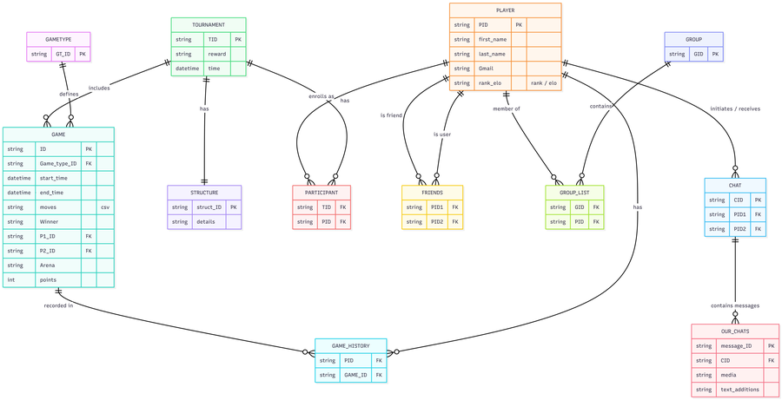
Figure 2 — Game & Tournament Flow

2. Entity-Relationship Diagrams
Two complementary ERDs are presented: a detailed relational ERD with full attribute tables, and a high-level conceptual ERD showing entities and relationships only. Together they provide a complete picture of the database design.

2.1 Detailed Relational ERD
The detailed ERD below shows all tables with their attributes, data types, primary keys (PK), and foreign keys (FK). Junction tables are shown with composite primary keys.

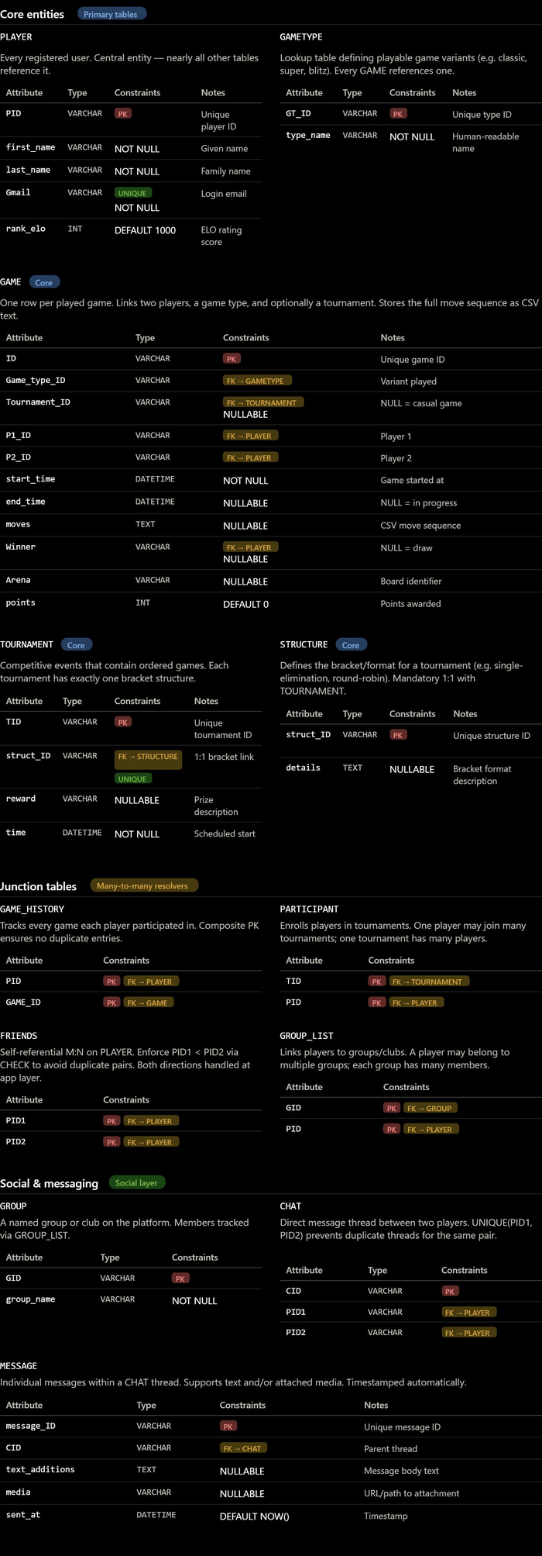
Figure 3 — Full Detailed ERD (all attributes, PKs & FKs)

2.2 High-Level Conceptual ERD
The conceptual ERD below strips away attribute details to reveal only the entities and their crow's-foot cardinality relationships, making it easier to reason about the overall database structure.

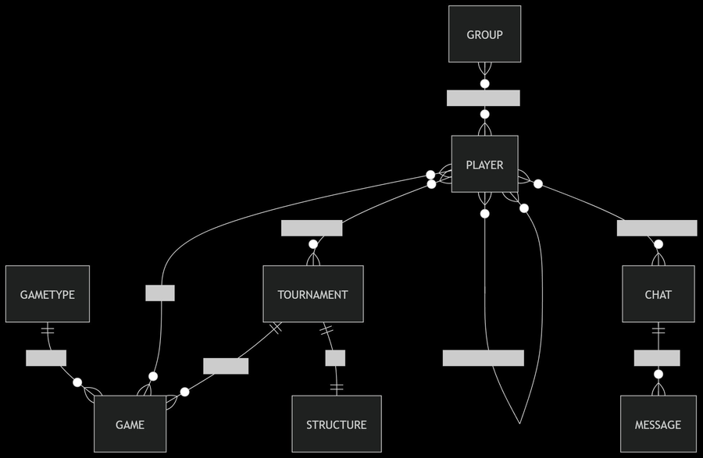
Figure 4 — Conceptual ERD (entities & relationships only)

3. Relational Database Schema Description
This section describes every table in the database — its purpose, attributes, data types, constraints, and relationships to other tables. The schema is designed for a Super Tic-Tac-Toe multiplayer platform supporting ranked play, tournaments, social features, and chat.

3.1 GAMETYPE
Lookup table defining the variants of Tic-Tac-Toe available on the platform (e.g. Classic, Blitz, Super, Ultimate). Every game instance references one game type, keeping the GAME table normalised and variant rules centralised.

Attribute | Type | Constraint | Description
GT_ID | VARCHAR | PK | Unique identifier for the game variant (e.g. 'GT_CLASSIC')
type_name | VARCHAR | NOT NULL | Human-readable name of the variant (e.g. 'Classic 3×3')
description | TEXT | NULLABLE | Brief description of rules and differences from standard play
max_duration_sec | INT | DEFAULT 300 | Maximum allowed duration per game in seconds
is_ranked | BOOLEAN | DEFAULT TRUE | Whether ELO rating changes apply to this game type

3.2 PLAYER
Central entity representing every registered user of the platform. Almost all other tables reference PLAYER. Stores identity, login credentials (email), and the ELO rating that drives the competitive ranking system.

Attribute | Type | Constraint | Description
PID | VARCHAR | PK | Unique player identifier (UUID or slug, e.g. 'PLR_00421')
first_name | VARCHAR | NOT NULL | Player's given name
last_name | VARCHAR | NOT NULL | Player's family name
Gmail | VARCHAR | UNIQUE, NOT NULL | Login email — must be unique across all players
rank_elo | INT | DEFAULT 1000 | ELO rating score; higher = stronger player
country | VARCHAR | NULLABLE | Player's country for regional leaderboards
avatar_url | VARCHAR | NULLABLE | URL to the player's profile picture
created_at | DATETIME | DEFAULT NOW() | Timestamp when the account was registered
is_active | BOOLEAN | DEFAULT TRUE | Soft-delete flag; FALSE = account deactivated

3.3 GAME
Records every single game instance played on the platform. Links two players, a game type, and optionally a tournament. Stores the full move sequence as CSV-encoded text, enabling replay and analytics. NULL in end_time means the game is still in progress.

Attribute | Type | Constraint | Description
ID | VARCHAR | PK | Unique game identifier
Game_type_ID | VARCHAR | FK → GAMETYPE | Which variant is being played
Tournament_ID | VARCHAR | FK → TOURNAMENT, NULL | Owning tournament; NULL for casual (unranked) games
P1_ID | VARCHAR | FK → PLAYER | Player occupying the first seat (usually starts first)
P2_ID | VARCHAR | FK → PLAYER | Player occupying the second seat
start_time | DATETIME | NOT NULL | UTC timestamp when the game began
end_time | DATETIME | NULLABLE | UTC timestamp when the game ended; NULL = in progress
moves | TEXT | NULLABLE | CSV-encoded move sequence for full replay (e.g. '0,4,1,5,…')
Winner | VARCHAR | FK → PLAYER, NULL | PID of the winner; NULL = draw or in-progress game
Arena | VARCHAR | NULLABLE | Board/arena identifier for themed game sessions
points | INT | DEFAULT 0 | ELO points awarded to the winner from this game
status | VARCHAR | DEFAULT 'active' | Game lifecycle state: active | finished | abandoned

3.4 GAME_HISTORY (Junction Table)
Resolves the many-to-many relationship between PLAYER and GAME. Each row records one player's participation in one game. The composite primary key (PID, GAME_ID) prevents duplicate entries and ensures a player cannot be linked to the same game twice.

Attribute | Type | Constraint | Description
PID | VARCHAR | PK, FK → PLAYER | The participating player
GAME_ID | VARCHAR | PK, FK → GAME | The game the player participated in
result | VARCHAR | NULLABLE | Outcome for this player: win | loss | draw
elo_change | INT | NULLABLE | Net ELO points gained or lost by this player in this game

3.5 TOURNAMENT
Represents a competitive event that contains an ordered set of games. Each tournament has exactly one bracket structure (1:1 with STRUCTURE), an optional prize, and a scheduled start time. Games that belong to a tournament reference it via GAME.Tournament_ID.

Attribute | Type | Constraint | Description
TID | VARCHAR | PK | Unique tournament identifier
struct_ID | VARCHAR | FK → STRUCTURE, UNIQUE | Bracket definition; UNIQUE enforces the mandatory 1:1 relationship
name | VARCHAR | NOT NULL | Display name of the tournament (e.g. 'Spring Open 2026')
reward | VARCHAR | NULLABLE | Prize or reward description (e.g. 'Gold Badge + 500 ELO')
time | DATETIME | NOT NULL | Scheduled UTC start time of the tournament
max_participants | INT | NULLABLE | Cap on the number of enrolled players; NULL = unlimited
status | VARCHAR | DEFAULT 'upcoming' | Lifecycle: upcoming | ongoing | completed | cancelled

3.6 STRUCTURE
Defines the bracket or format of a tournament (e.g. single-elimination, round-robin, Swiss). Kept as a separate table to allow reuse of common formats and to keep TOURNAMENT normalised. Mandatory 1:1 with TOURNAMENT.

Attribute | Type | Constraint | Description
struct_ID | VARCHAR | PK | Unique structure identifier
format_type | VARCHAR | NOT NULL | Format kind: single-elim | round-robin | swiss | double-elim
details | TEXT | NULLABLE | Full description or JSON config of the bracket
rounds | INT | NULLABLE | Total number of rounds (if applicable to format)

3.7 PARTICIPANT (Junction Table)
Resolves the many-to-many relationship between PLAYER and TOURNAMENT, tracking which players have enrolled in which tournaments. The composite PK (TID, PID) ensures a player cannot be registered more than once in the same tournament.

Attribute | Type | Constraint | Description
TID | VARCHAR | PK, FK → TOURNAMENT | Tournament the player is enrolled in
PID | VARCHAR | PK, FK → PLAYER | The enrolled player
seed | INT | NULLABLE | Seeding position within the tournament bracket
enrolled_at | DATETIME | DEFAULT NOW() | Timestamp of enrolment
eliminated | BOOLEAN | DEFAULT FALSE | TRUE once the player is knocked out

3.8 FRIENDS (Junction Table — Self-Referential)
Resolves the many-to-many self-referential relationship on PLAYER to model bilateral friendships. The convention PID1 < PID2 (enforced at the application layer or via CHECK constraint) avoids storing both orderings of the same pair.

Attribute | Type | Constraint | Description
PID1 | VARCHAR | PK, FK → PLAYER | First player in the friendship (lower PID by convention)
PID2 | VARCHAR | PK, FK → PLAYER | Second player in the friendship (higher PID by convention)
since | DATETIME | DEFAULT NOW() | Timestamp when the friendship was formed
status | VARCHAR | DEFAULT 'accepted' | Friendship state: pending | accepted | blocked

3.9 GROUP
Represents a named club or community within the platform. Players can belong to multiple groups and each group can have many members, managed via the GROUP_LIST junction table.

Attribute | Type | Constraint | Description
GID | VARCHAR | PK | Unique group identifier
group_name | VARCHAR | NOT NULL | Display name of the group
description | TEXT | NULLABLE | Purpose or description of the group
owner_PID | VARCHAR | FK → PLAYER, NOT NULL | PID of the player who created and owns the group
created_at | DATETIME | DEFAULT NOW() | Timestamp of group creation
is_public | BOOLEAN | DEFAULT TRUE | TRUE = open to join; FALSE = invite-only

3.10 GROUP_LIST (Junction Table)
Resolves the many-to-many relationship between PLAYER and GROUP, tracking group membership. The composite PK (GID, PID) prevents duplicate memberships.

Attribute | Type | Constraint | Description
GID | VARCHAR | PK, FK → GROUP | The group
PID | VARCHAR | PK, FK → PLAYER | The member player
role | VARCHAR | DEFAULT 'member' | Member's role within the group: owner | admin | member
joined_at | DATETIME | DEFAULT NOW() | Timestamp when the player joined

3.11 CHAT
Represents a direct message thread between exactly two players. The UNIQUE constraint on (PID1, PID2) prevents duplicate threads for the same pair. All messages within a thread are stored in the MESSAGE table and linked via CID.

Attribute | Type | Constraint | Description
CID | VARCHAR | PK | Unique chat thread identifier
PID1 | VARCHAR | FK → PLAYER | Initiating player
PID2 | VARCHAR | FK → PLAYER | Receiving player
created_at | DATETIME | DEFAULT NOW() | When the chat thread was opened
last_message_at | DATETIME | NULLABLE | Timestamp of the most recent message (for sorting inbox)

3.12 MESSAGE
Stores individual messages within a CHAT thread. Supports both text messages and media attachments (images, files). Automatically timestamped at insertion. Previously named OUR_CHATS in the initial design — renamed to MESSAGE for clarity.

Attribute | Type | Constraint | Description
message_ID | VARCHAR | PK | Unique message identifier
CID | VARCHAR | FK → CHAT | Parent chat thread
sender_PID | VARCHAR | FK → PLAYER | PID of the player who sent the message
text_additions | TEXT | NULLABLE | Text content of the message
media | VARCHAR | NULLABLE | URL or server path to an attached image or file
sent_at | DATETIME | DEFAULT NOW() | UTC timestamp of when the message was sent
is_read | BOOLEAN | DEFAULT FALSE | TRUE once the recipient has opened the message

4. Relationships Summary
All many-to-many relationships are resolved using junction tables. One-to-many and one-to-one relationships are managed through foreign key columns on the dependent table.

Relationship | Table A | Table B | Cardinality | Junction Table
Player plays Game | PLAYER | GAME | M:N | GAME_HISTORY
Player joins Tournament | PLAYER | TOURNAMENT | M:N | PARTICIPANT
Player friends with Player | PLAYER | PLAYER | M:N (self) | FRIENDS
Player belongs to Group | PLAYER | GROUP | M:N | GROUP_LIST
Player chats via Chat | PLAYER | CHAT | 1:M | —
GameType defines Game | GAMETYPE | GAME | 1:M | —
Tournament includes Game | TOURNAMENT | GAME | 1:M | —
Tournament has Structure | TOURNAMENT | STRUCTURE | 1:1 | —
Chat contains Message | CHAT | MESSAGE | 1:M | —

5. Key Constraints Summary

Table | Primary Key | Foreign Keys
GAMETYPE | GT_ID | —
PLAYER | PID | —
GAME | ID | Game_type_ID, Tournament_ID, P1_ID, P2_ID, Winner
GAME_HISTORY | (PID, GAME_ID) | PID → PLAYER, GAME_ID → GAME
TOURNAMENT | TID | struct_ID → STRUCTURE
STRUCTURE | struct_ID | —
PARTICIPANT | (TID, PID) | TID → TOURNAMENT, PID → PLAYER
FRIENDS | (PID1, PID2) | PID1 → PLAYER, PID2 → PLAYER
GROUP | GID | owner_PID → PLAYER
GROUP_LIST | (GID, PID) | GID → GROUP, PID → PLAYER
CHAT | CID | PID1 → PLAYER, PID2 → PLAYER
MESSAGE | message_ID | CID → CHAT, sender_PID → PLAYER

6. Referential Integrity Notes
The following rules must be enforced either by the DBMS or at the application layer:

- GAME.Winner is a nullable FK to PLAYER — NULL represents a draw or an in-progress game.
- GAME.Tournament_ID is nullable — not every game belongs to a tournament (casual play allowed).
- FRIENDS requires PID1 ≠ PID2 (CHECK constraint) to prevent self-friendship entries.
- CHAT must enforce UNIQUE(PID1, PID2) to prevent duplicate DM threads for the same pair.
- STRUCTURE is in a mandatory 1:1 with TOURNAMENT via a UNIQUE FK on TOURNAMENT.struct_ID.
- All junction table FKs should use ON DELETE CASCADE to maintain referential integrity.
- PLAYER.rank_elo should be updated atomically after each ranked game via a transaction.
- MESSAGE.sender_PID must be either CHAT.PID1 or CHAT.PID2 — enforced at the application layer.

7. Design Decisions & Notes
Several deliberate design choices were made during schema normalisation:

- GAME stores moves as CSV text to keep the schema simple. For advanced analytics, a separate MOVE table (game_id, move_number, position, player_pid) could be introduced.
- ELO history is tracked per-game via GAME_HISTORY.elo_change, enabling full rating history reconstruction.
- The FRIENDS table uses the convention PID1 < PID2 to avoid storing both directions of each friendship, halving storage for this symmetric relation.
- GROUP separates the owner (owner_PID FK) from ordinary membership tracked in GROUP_LIST, allowing fine-grained role management.
- TOURNAMENT.max_participants is nullable to support open-enrollment events without a hard cap.
- MESSAGE was renamed from OUR_CHATS and a sender_PID FK was added to clearly identify who sent each message.

